

**REPORT ON THE TOPIC OF**

**Movie-BOOKING MANAGENT SYSTEM**

**SUBMITTED TO** – Mr. Moin Hassan

(PROFESSOR CSE326)

**Submitted By –**

SUMIT PRADHAN (40) (11912387)

Vishwanath Pratap Singh (41) (11912424)(GL)

Divya Sharma (42) (11912430)

**Section**- K19Pt

**Group**- II

METHODOLOGY

The main aim of this booking management system is to make the process of booking movie tickets for the customers more easy, efficient and reliable. Movies Booking Management System helps to manage the details of different types of bookings like bookings of movie tickets, its seats at back, front or middle, special booking is also provided. The purpose of the project is to build a website or an application program to reduce the manual work for managing the Bookings of Movie Tickets, Hotels, Restaurant Table etc. and also the customer’s details and payments details also. It also helps to reduce the unnecessary use of papers and it is very efficient and smart to use a booking system.

INTRODUCTION

In today's busy and stressful generation, everyone wants his or her work to be done easily whether the work is to clean the house or it is to walk. Most people, especially our young ones are stressed or busy in some kind of hectic work, for these people we are giving them a platform to release their stress and make their work little bit enjoyable and could feel relaxed. The way to make them feel relaxed is movie bookings. Lots of people waste their time in movie bookings, to save customer’s precious time and for fast service we are providing the best site for them by which they can book their movie tickets anytime when it's required and also at affordable prices.

LITERATURE REVIEW

Provides the searching facilities based on various factors. Such as Price, Bookings, Services, Payments. Booking Management System also manages the Customers details online for Payments details,Booking details. Manages the information of movies seats, movies etc. Shows the information and description of the Services. To increase the efficiency of managing bookings. It deals with the information and transactions of Payments. Integration of all records of Bookings.

Proposed methodology

For developing this project we have taken help of three methods such as:-

* HTML
* JavaScript
* CSS.

These three had been very helpful in the process of developing this html project. We definitely came to learn and understand more about these things. This project helped us to know more about how websites and webpages are developed.

RESULT AND DECLARATION

Our team had worked brilliantly on this project in order to make this project successful. Here we gladly present some of the pictures of our Project which is booking management system. 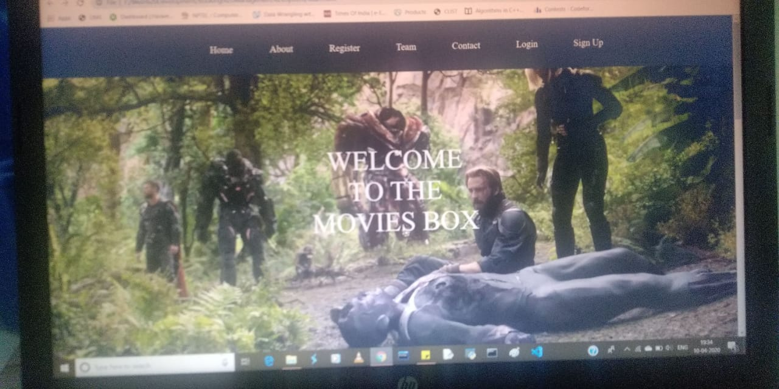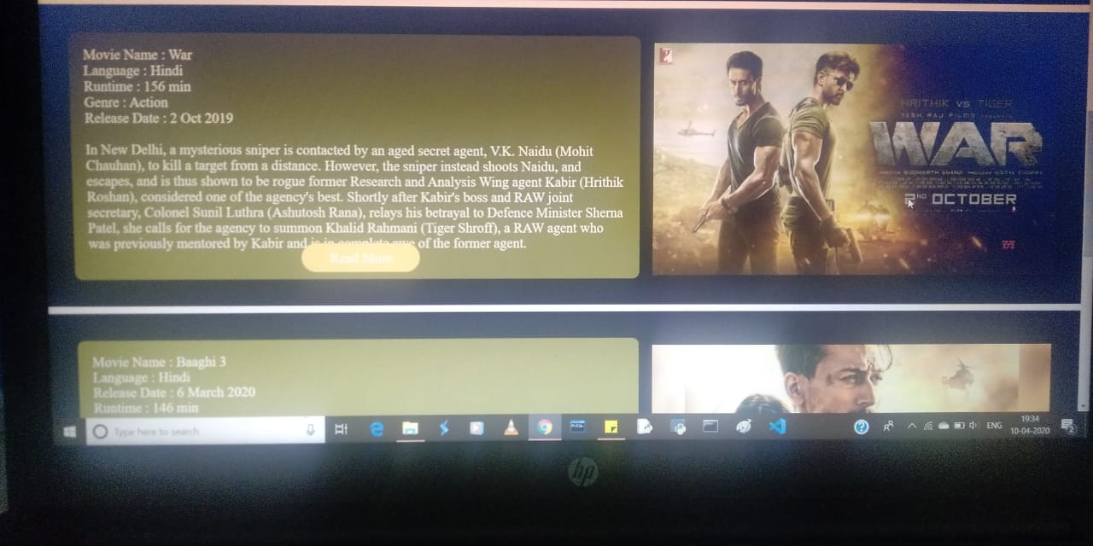

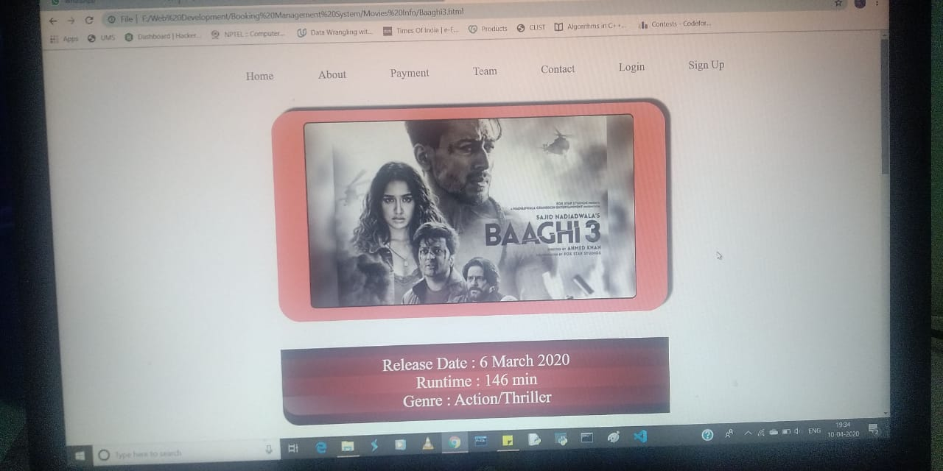

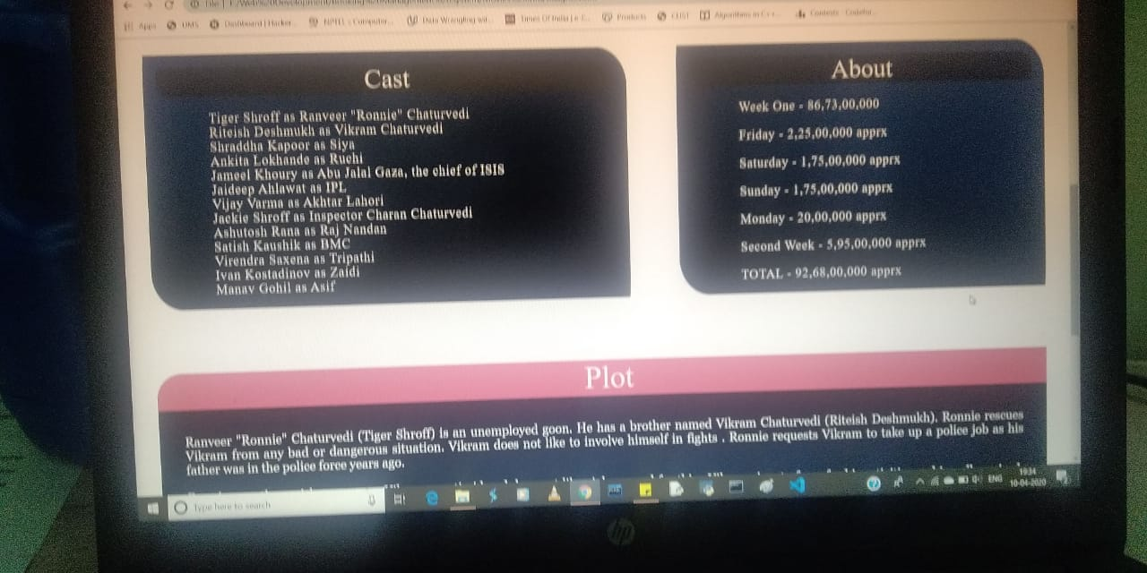

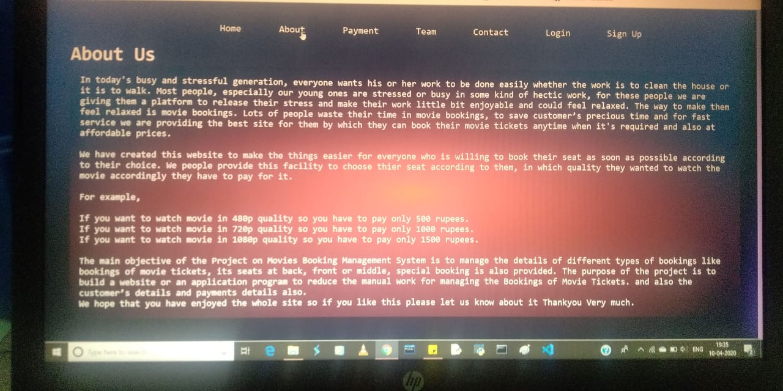

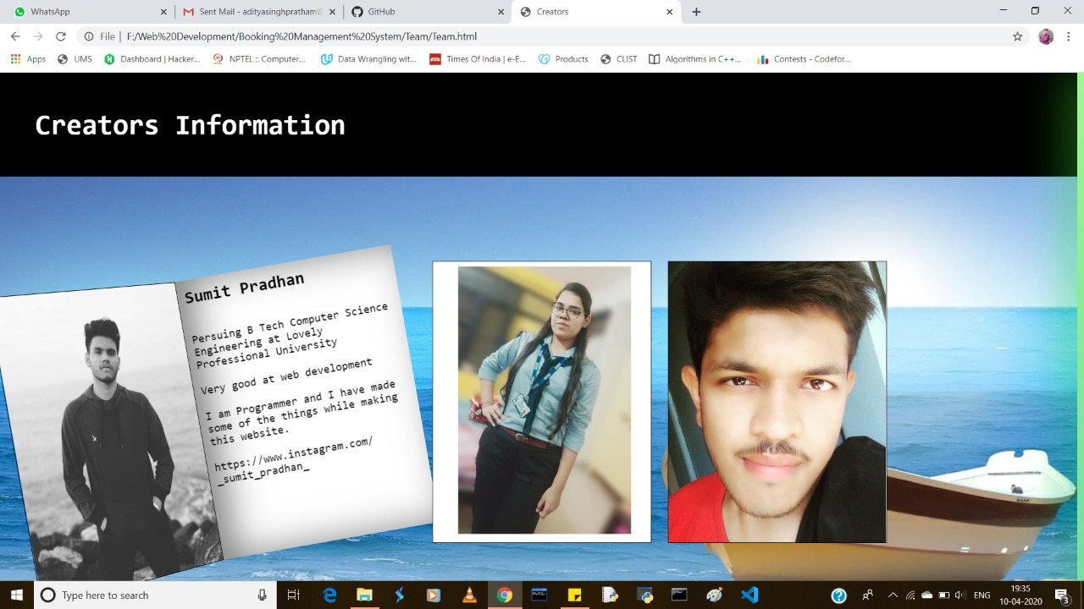

CONCLUSION

Movie-Booking management system is very effective, efficient, reliable and economic from all aspects. It provides all current needs of a client when it comes to Movie Booking Management System. The proposed project is very flexible, so new features and modules can be added in future as per user requirements.

REFERENCES

We have taken references from these places in order get better idea ion web development, html, CSS and JavaScript. And these sources have proved to be very in the process of web page development. Those sources are:-

* [www.wikipedia.com](http://www.wikipedia.com)
* [www.W3schools.com](http://www.W3schools.com)
* [www.tutorialspoint.com](http://www.tutorialspoint.com)
* [www.youtube.com](http://www.youtube.com)
* Udemy
* CodecAcademy

CONTRIBUTIONS

**Vishwanath Pratap Singh (Group Leader):**

I have contributed in the writing part of the codes which were required to develop the project.

I have also worked on the designing part of the part. Being the group leader I distributed the total

Work of the project among the group members equally. If any of the member was reluctant while

Doing his/her work then I successfully motivated and guided them properly. I worked on reducing

The errors in the project and tried making the project more bugs free. I have also worked on

The Animation of various segments.

**Sumit Pradhan (Group Member):**

He has contributed in the research work for the development of the project. He helped in

Gathering ideas from different sources like Wikipedia, YouTube, books and from several other

Web Development Platforms. He has also worked on designing part of the project and helped in

Designing the homepage and login page. He had been a great companion and proved to be very

Helpful in the journey of the development of project.

**Divya Sharma (Group Member):**

She has contributed in making the Webpages more attractive and decorative. In order to provide

The user a visual treat while opening the webpages. She has worked on gathering important

Information which were essential regarding the development of the project and all the research

Works. She has also worked on deigning of the homepages. She had been very helpful in the

course of designing of the project.